1. Verify that your ansible installation is available by displaying the version of ansible while logged in as the 'user' user.

[test@tcox3 ~]$ ansible --version

ansible 1.9.2

  configured module search path = None

2. Run the ansible command that lists all of the hosts configured in your control server 'hosts' file for the system.

[test@tcox3 ~]$ ansible all --list-hosts

    tcox5.mylabserver.com

    localhost

    tcox4.mylabserver.com

3. Using the 'setup' module for ansible, list all of the known facts on the local system.

[test@tcox3 ~]$ ansible local -m setup

localhost | success >> {

    "ansible_facts": {

        "ansible_all_ipv4_addresses": [

            "172.31.107.208"

        ],

        "ansible_all_ipv6_addresses": [

            "fe80::103f:68ff:fefe:2bd1"

        ],

        "ansible_architecture": "x86_64",

        "ansible_bios_date": "05/06/2015",

        "ansible_bios_version": "4.2.amazon",

        "ansible_cmdline": {

            "BOOT_IMAGE": "/boot/vmlinuz-3.10.0-229.14.1.el7.x86_64",

        (NOTE: Your output will be larger as this was concatenated for space and readability)

4. Using the 'setup' module for ansible, list all of the known facts for all systems configured in the 'hosts' file on the system.

[test@tcox3 ~]$ ansible all -m setup

(NOTE: Localhost truncated here... starting with another host output)

tcox4.mylabserver.com | success >> {

    "ansible_facts": {

        "ansible_all_ipv4_addresses": [

            "172.31.108.45"

        ],

        "ansible_all_ipv6_addresses": [

            "fe80::1029:fbff:fed6:9aaf"

        ],

        "ansible_architecture": "x86_64",

        "ansible_bios_date": "05/06/2015",

        "ansible_bios_version": "4.2.amazon",

        "ansible_cmdline": {

            "BOOT_IMAGE": "/boot/vmlinuz-3.10.0-229.14.1.el7.x86_64",

   (NOTE: Your output will be larger as this was concatenated for space and readability)

5. While listing the facts on the local system, filter the list showing only the content pertaining to the system IP addresses.

[test@tcox3 ~]$ ansible local -m setup -a 'filter=ans*ipv4*'

localhost | success >> {

    "ansible_facts": {

        "ansible_all_ipv4_addresses": [

            "172.31.107.208"

        ],

        "ansible_default_ipv4": {

            "address": "172.31.107.208",

            "alias": "eth0",

            "gateway": "172.31.96.1",

            "interface": "eth0",

            "macaddress": "12:3f:68:fe:2b:d1",

            "mtu": 9001,

            "netmask": "255.255.240.0",

            "network": "172.31.96.0",

            "type": "ether"

        }

    },

    "changed": false

Lab :

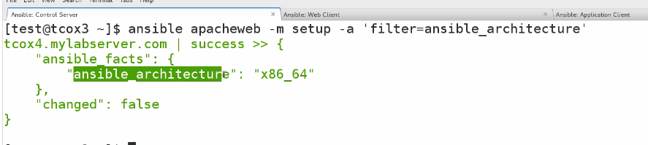

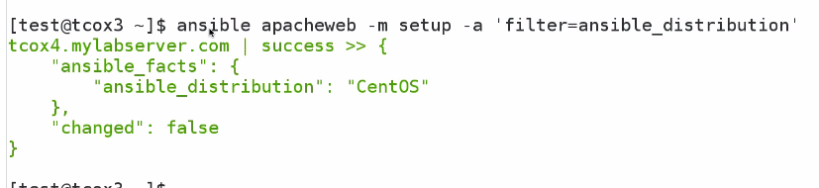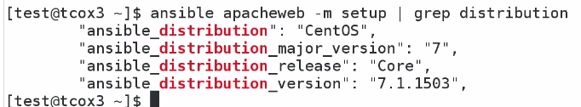

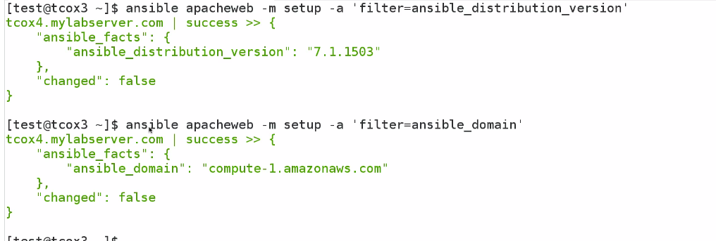

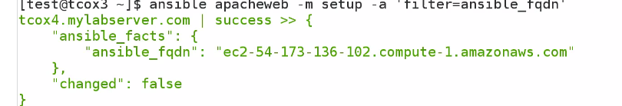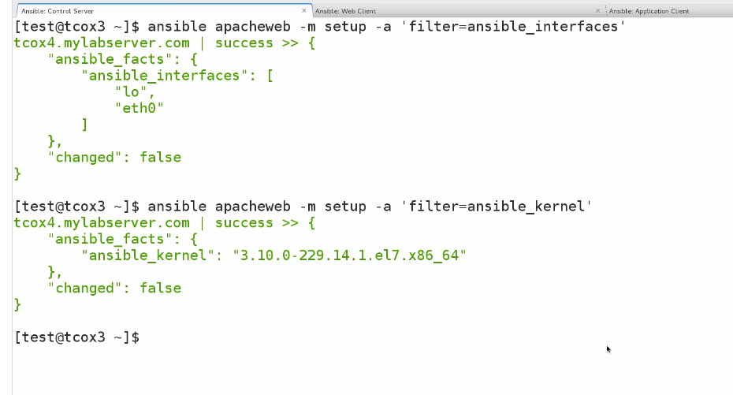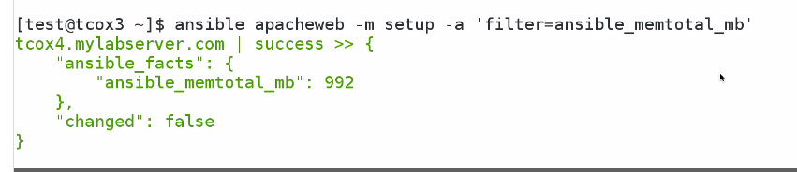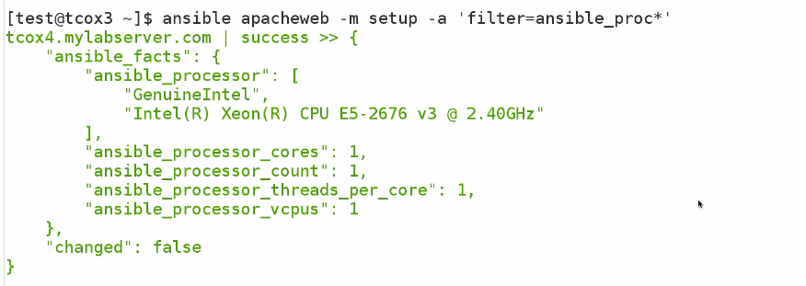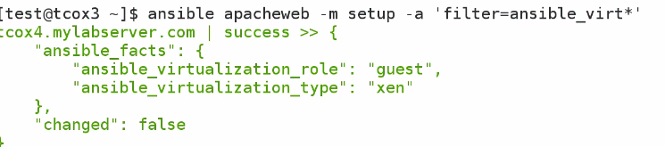

Python must be installed to gather fact